# In Memory Computing Term Paper

## By Rajat Vij

# Abstract

This term paper explores the concept of In Memory Computing and discusses the changes it might bring the Disk Storage is used in future. From hardware based point of view data analysis consists of three components: the processor to perform the calculations, the storage to store the (manipulated) data and a system that transfers data between the two. The slowest of these components is the performance of IT based data analysis. In which the current bottleneck is latency of storage (hard disk storage specifically). In Memory Computing is an emerging technology that lets user have immediate access to write information, which results in more informed decisions and saves time as compared to traditional Business Intelligence Technology. "In Memory" means having physical database being in memory (RAM or flash) rather than on disk storage. So, this saves time on data modelling, query analysis, table designs and promises a massive gain in speed. The reason why In Memory Computing wasn’t used before was the massive cost of RAM or Flash. But recently, the costs are dropping at a rate of 32% p.a. and In Memory Computing is becoming a reality and efficient usage of memory reduces the power consumption by 99%. That's why with the ongoing trends In Memory Computing is expected to implement in mainstream Data Analytics. Aside from having a potential of getting 1000 times faster processing speed, in memory architecture allows data views to be generated on-the-fly, a benefit that not only reduces database footprint and storage requirements, but also potentially simplifies the modelling and deployment of data and the design.

Table of Contents

Abstract 2

Introduction 4

What is in-memory computing? 5

Why now? 7

Why is it time for in-memory computing? 7

Why is it popular? 7

Why choose In-Memory Computing 8

Advantages of Using In-Memory Computing 10

Challenges to In-Memory Computing 11

Challenges 11

Inhibitors of in-memory computing adoption 11

In-memory myths 13

What’s next? 15

Step forward 15

In-Memory Computing and Big Data 15

Usage in Real world 16

Business impact of in-memory computing 18

Run the business 18

Transform the business 19

In-memory computing technologies 21

Drivers of in-memory computing 23

Why you need an in-memory action plan 25

Expectation 27

In-memory is going to change the way everything is done 27

References 28

# Introduction

In-memory computing means using a type of middleware software that allows one to store data in RAM, across a cluster of computers, and process it in parallel. Consider operational datasets typically stored in a centralized database, which we can now store in “connected” RAM across multiple computers. RAM, roughly, is 5,000 times faster than traditional spinning disk. Add to the mix native support for parallel processing, and things get very fast. Really, really, fast.

RAM storage and parallel distributed processing are two fundamental pillars of in-memory computing. While in-memory data storage is expected of in-memory technology, the parallelization and distribution of data processing, which is an integral part of in-memory computing, calls for an explanation.

Parallel-distributed processing capabilities of in-memory computing are a technical necessity. Consider this: a single modern computer can hardly have enough RAM to hold a significant dataset. In fact, a typical x86 server today (mid-2014) would have somewhere between 32GB to 256GB of RAM. Although this could be a significant amount of memory for a single computer, that’s not enough to store many of today’s operational datasets that easily measure in terabytes.

To overcome this problem in-memory computing software is designed from the ground up to store data in a distributed fashion, where the entire dataset is divided into individual computers’ memory, each storing only a portion of the overall dataset. Once data is partitioned – parallel distributed processing becomes a technical necessity simply because data is stored this way.

Developing technology that enables in-memory computing and parallel processing is highly challenging and is the reason there are literally less than 10 companies in the world that have mastered the ability to produce commercially available in-memory computing middleware. But for end users of in-memory computing, they are now able to enjoy dramatic performance benefits from this “technical necessity”.

Put simply, in-memory computing primarily relies on keeping data in a server's RAM as a means of processing at faster speeds. In-memory computing especially applies to processing problems that require extensive access to data –analytics, reporting or data warehousing, and big data applications.

## What is in-memory computing?

[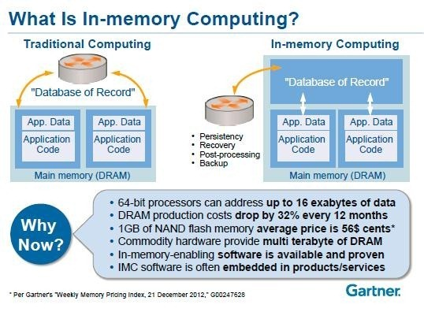](http://timoelliott.com/blog/wp-content/uploads/2013/04/what-is-in-memory.jpg)

When we talk about in-memory computing, we are talking about DRAM: the “d” stands for destructive: it doesn’t hold data it if we lose power. It’s not about flash or NAND memory. Flash is a form of memory, but it’s not what we’re talking about when we talk about in-memory computing.

All forms of flash today are used like disk drives. Even though we may remove the controller as a bottleneck, the applications are still doing I/O to a flash drive or a flash board. It is getting much more reliable and cheaper, so it is going to become a persistence mechanism replacing disk.

Today, the reliability of flash is longer than that of disk drives. If we replace our hardware every three to four years, and we have flash SSD and disk, we will probably not see a failure on the flash at all in that period of time, but we will be required to change disk drives.

When we talk about in-memory, we are talking about the physical database being in-memory rather than as it is “traditionally” done: on disk.

What is the difference? Database engines today do I/O. So if they want to get a record, they read. If they want to write a record, they write, update, delete, etc. The application, which in this case is a DBMS, thinks that it’s always writing to disk. If that record that they’re reading and writing happens to be in flash, it will certainly be faster, but it’s still reading and writing. Even if we’ve cached it in DRAM, it’s the same thing: We are still reading and writing.

What we’re talking about here is the actual database is physically in in-memory. We are doing a fetch to get data and not a read. So the logic of the database changes. That’s what in-memory is about as opposed to the traditional types of computing.

# Why now?

## Why is it time for in-memory computing?

Why now? The most important thing is this: DRAM costs are dropping about 32% every 12 months. Things are getting bigger, and costs are getting lower. If we look at the price of a Dell server with a terabyte of memory three years ago, it was almost $100,000 on their internet site. Today, a server with more cores — sixteen instead of twelve — and a terabyte of DRAM, costs less than $40,000.

## Why is it popular?

In-memory computing is the storage of information in the main random access memory (RAM) of dedicated servers rather than in complicated relational databases operating on comparatively slow disk drives. In-memory computing helps business customers, including retailers, banks and utilities, to quickly detect patterns, analyze massive data volumes on the fly, and perform their operations quickly. The drop in memory prices in the present market is a major factor contributing to the increasing popularity of in-memory computing technology. This has made in-memory computing economical among a wide variety of applications.

In-memory processing has become popular due to the drop in computer memory prices, exponential data growth and an increasing trend toward using analytics for decision-making.

Now that RAM is has come down in cost, in-memory computing is used to speed access to results from data-intensive processing problems. The expectation used to be that analytic reports would be started and results would come later (i.e. "coffee break analytics"). In-memory computing has revolutionized this so that results are available for real-time decision-making and further drill-down analysis of the results can be performed at will.

## Why choose In-Memory Computing

Let’s get this out of the way first: if one wants a 2-3x performance or scalability improvements – flash storage (SSD, Flash on PCI-E, Memory Channel Storage, etc.) can do the job. It is relatively cheap and can provide that kind of modest performance boost.

To see, however, what a difference in-memory computing can make, consider this real-live example.

Last year GridGain won an open tender for one of the largest banks in the world. The tender was for a risk analytics system to provide real-time analysis of risk for the bank’s trading desk (common use case for in-memory computing in the financial industry). In this tender GridGain software demonstrated one billion business transactions per second on 10 commodity servers with the total of 1TB of RAM. The total cost of these 10 commodity servers is less than $25K.

Now, read the previous paragraph again: **one billion financial transactions per second on $25K worth of hardware.** That is the in-memory computing difference — not just 2-3x times faster; more than 100x faster than theoretically possible even with the most expensive flash-based storage available on today’s market (forget about spinning disks). And 1TB of flash-based storage alone would cost 10x of entire hardware setup mentioned.

Importantly, that performance translates directly into the clear **business value**:

* We can use less hardware to support the required performance and throughput SLAs, get better data center consolidation, and significantly reduce capital costs, as well as operational and infrastructure overhead, and
* We can also significantly extend the lifetime of our existing hardware and software by getting increased performance and improve its ROI by using what we already have longer and making it go faster.

**And that’s what makes in-memory computing such a hot topic these days:** the demand to process ever growing datasets in real-time can now be fulfilled with the extraordinary performance and scale of in-memory computing, with economics so compelling that the business case becomes clear and obvious.

Many technology companies are making use of this technology. For example, the in-memory computing technology developed by SAP, called High-Speed Analytical Appliance (HANA), uses a technique called sophisticated data compression to store data in the random access memory. HANA's performance is 10,000 times faster when compared to standard disks, which allows companies to analyze data in a matter of seconds instead of long hours.

**In-memory results in lower total cost of ownership**

So the cost of this stuff is not outrageous. For those of us who don’t understand storage, I always get into this argument: the total cost of acquisition of an in-memory system is likely higher than a storage system. There’s no question. But the total cost of TCO is lower – because we don’t need storage people to manage memory. There are no LUNs [logical unit numbers]: all the things our storage technicians do goes away.

People cost more than hardware and software – a lot more. So the TCO is lower. And also, by the way, power: one study IBM did showed that memory is 99% less power than spinning disks. So unless we happen to be an electrical company, it’s going to mean a lot to us. Cooling is lower, everything is lower.

**So don’t let somebody say that we can’t go in-memory because it’s so much more money. Acquisition costs may be higher. If we calculate out a TCO, it’s going to be less.**

# Advantages of Using In-Memory Computing

* **Operate at the Highest Speeds Available:** Give information zero latency, including analytics for data-in-motion and data-at-rest.
* **Reduce Cost:** Use commodity hardware to support fast performance without having to manage the details, including scaling in the cloud.
* **Extend the Life of Existing Applications:** Make them faster and more distributed using in-memory computing as middleware.
* **Lean Forward:** Combine the functionality of database and messaging at real-time speeds.
* **Cash in on the Big Data Promise:** Make decisions based on all our data.
* **Scale As Needed:** Scale flexibly depending on our processing requirements in real time.
* The ability to cache countless amounts of data constantly. This ensures extremely fast response times for searches.
* The ability to store session data, allowing for the customization of live sessions and ensuring optimum website performance.
* The ability to process events for improved complex event processing
* **Better, faster, decision-making.** This includes the ability to reduce cost, identify competitive opportunities, grow revenue, become more efficient and reduce risk.

# Challenges to In-Memory Computing

## Challenges

* One challenge with in-memory computing is that most solutions require massive data sets to fit into RAM in order to process a query. This is a brute force processing method that is not sustainable as data volumes continue to explode in a big data world.
* Consider a sensor device at a utility company, for example, where each sensor can generate as much as 400 MB of data per meter per year. Multiply this by the tens of thousands of meters the company may have available. Or, think of an application generating terabytes of data per day. Fitting all of this data into memory in order to process it is not a sustainable proposition.
* Also, modern servers are capable of processing data at CPU speeds faster than the speed at which RAM can be accessed—making the speed of RAM access a bottleneck.
* New solutions are needed to process data at the fastest speed – the CPU speed. More sophisticated management of data is required to replace the brute force approach of fitting the entire data set into memory no matter its size.

## Inhibitors of in-memory computing adoption

**So what’s slowing us down?**

A lot of these are perceptions. So the perception that it’s a complex architecture: it doesn’t have to be.

The perception that it’s unrealistic: today, this technology is emerging, and yes, it’s disruptive, but no, we can’t do everything with it. So the expectations have to be set right. There are of course no standards, there aren’t a lot of skills and there’s not a lot of best practices yet, because this is just emerging with those. That will happen over the next few years.

So yes, there are many drivers, but at the same time there are many inhibitors, a lot, of which we can change by setting expectations and perceptions correctly. So we start to think about IT looking at all this data and saying “what do we do with it all?” and the bottom line is: **if our assumptions are that we can’t do anything with it, we’re not going to do anything with it.**

# In-memory myths

[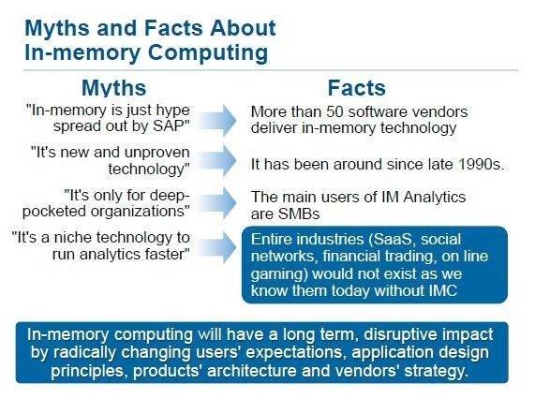](http://timoelliott.com/blog/wp-content/uploads/2013/04/in-memory-myths3.jpg)

* **It’s new and unproven?** Wrong. We have been using in-memory technology since the 90s. We’re not talking here about caching in-memory. We did that in with [360s](http://en.wikipedia.org/wiki/IBM_System/360), with only 24k of memory. In-memory technologies that actually use in-memory not for cache, but for actual data that they fetch and change, has been around since the early 90s.
* **That in-memory technology is expensive and only if you have really deep pockets can you afford it?** Not true. There are several in-memory technology vendors whose largest customer base is SME, who by definition doesn’t have a lot of money to spend. And the cost of the technology is coming down fast.
* **And this is not a niche technology just for analytics**. We’re using it for all kinds of use cases today, such as trading fraud in the financial industry, for telephone fraud, for gaming where everything has to be instantaneous. Analytics will run faster, but it is not true that it’s only for analytics.

# What’s next?

## Step forward

TIBCO's in-memory computing technologies scale indefinitely without bottlenecks, configure to our persistence needs, and support the range of programs and platforms. These capabilities are a remarkable step forward in the support of operational decision-making, integration, and cost reduction – and make leveraging Big Data possible. With TIBCO in-memory computing technology, we have the power to analyze, understand, and predict opportunities and threats – and the advantage of preemptive action.

## In-Memory Computing and Big Data

Big Data is the popular term describing the fast-increasing volume, velocity, and variety of information that can help improve enterprise operations – but it is only part of the story. In-memory computing is the breakthrough that makes Big Data possible, that shatters performance barriers for applications including:

* Airline flight availability searches that need to include constantly changing flight records
* Personalized offers and optimal customer experiences on ecommerce websites
* Real-time reporting of mobile customer texting to enable pre-pay plans
* Extreme low-latency risk management and algorithmic trading applications
* Additional payment channels for faster revenue capture

# Usage in Real world

In-Memory Computing technology has been there since late 1990’s but wasn’t wide spread because of the high hardware costs. But with the decrease in the memory costs, it is being implemented in various industries such as:

* Investment banking
* Insurance claim processing & modeling
* Real-time ad platforms
* Real-time sentiment analysis
* Merchant platform for online games
* Hyper-local advertising
* Geospatial/GIS processing
* Medical imaging processing
* Natural language processing & cognitive computing
* Real-time machine learning
* Complex event processing of streaming sensor data

And we’re also seeing our solutions deployed for more mundane use cases, like speeding the response time of a student registration system from 45 seconds to under a half-second.

By looking at this list it becomes pretty obvious that the best use cases are defined not by specific industry but by the underlying technical need, i.e. the need to get the ultimate best and uncompromised performance and scalability for a given task.

In many of these real-life deployments in-memory computing was an enabling technology, the technology that made these particular systems possible to consider and ultimately possible to implement.

The bottom line is that in-memory computing is beginning to unleash a wave of innovation that’s not built on Big Data per se, but on Big Ideas, ideas that are suddenly attainable. It’s blowing up the costly economics of traditional computing that frankly can’t keep up with either the growth of information or the scale of demand.

As the Internet expands from connecting people to connecting things, devices like refrigerators, thermostats, light bulbs, jet engines and even heart rate monitors are producing streams of information that will not just inform us, but also protect us, make us healthier and help us live richer lives. We’ll begin to enjoy conveniences and experiences that only existed in science fiction novels. **The technology to support this transformation exists today – and it’s called in-memory computing.**

Industries actually started looking at in-memory technology at Gartner back in 2009 and in-memory databases have been around for years in some form going back to the 90s.

**This technology is now becoming disruptive.**

## Business impact of in-memory computing

[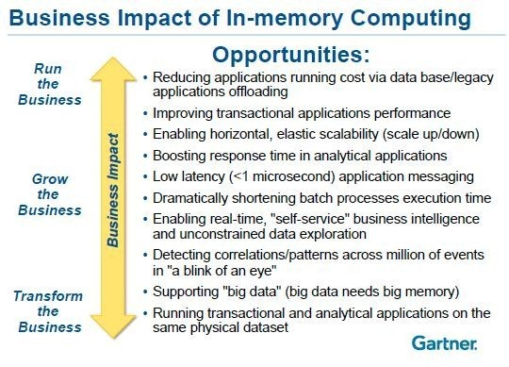](http://timoelliott.com/blog/wp-content/uploads/2013/04/business-impact-of-in-memory.jpg)

What is the impact of in-memory computing on our business? It’s about running the business, growing the business, and transforming the business, and we need to look at the business impact of this technology across all of these.

## Run the business

One of the biggest advantages of memory that people forget is this: right now, we have lots of applications. And today, people typically have one application per server. Let’s say we have our corporate running on ten servers today, and it’s spread out across locations, because of storage access and the speed of the processors and the speed of the applications and the database access.

If I can consolidate that down to a single server, I‘m going to save a lot of money, right off the bat. Not only power, floor space, cooling, but replacement costs every three to four years for ten or twenty servers is more than one. It’s not necessarily a single server — it may be one or two — but it’s going to be much fewer.

The people required to maintain it are going to be fewer, our maintenance costs per year are going to be less, and everything is less. So the speed of these in-memory technologies on just running our business – forget about transforming for a minute – is going to be a huge savings. Because **if one applications runs a hundred times faster on a server, I can get more applications on that server.**

## Transform the business

The latency with in-memory is so low that we can **do things synchronously that we wouldn’t have thought to do synchronously before**. It’s not only a matter of how many things we can do, and how much we can fit into this box because of the speed, but it’s also because of what the latency is going to give us.

Why is that important? Think about where information and mobile and social come together, and we need to do messaging and things like that. Because of this lower latency, we can start to do things we couldn’t even consider before, because we couldn’t get it fast enough to even think about it.

How many of us may have applications that we thought about doing, but because things took so long on our system, it’s just not reasonable to do? The program run that takes four to six hours overnight, now we can run it in five seconds according to the situation. So we can use the application differently.

And other things that we couldn’t do at all now become possible. As we start to do sentiment analysis, looking at social networks, and building it into a planning application that We’ll be running in seconds, that’s huge in the way we can change the way things are done.

Think about if somebody says “I want to buy 10,000 cases” and we don’t even know if we can produce that. And then he says, “I want it next week.”

How long does it take us to commit to that, and to figure out a price, that may in fact be higher because we’re going to bounce other customers off the production line in order to get this done? If we can do that with latency in seconds, it changes the way things are done.

That now is getting into “transform the business” because **an application that we view as “a forecasting package that runs overnight” is not a just a forecasting package if we can run it in five seconds or two minutes. It becomes a sales tool**, changing the way we can do business.

The example that I like to use is this: airlines want to sell you discount tickets. Most people don’t know that airlines re-price all the tickets on all their planes every night. So our company goes and buys a full-fare ticket because we need it refundable.

The next day, that flight may have two more discount tickets because they have a yield that they need for each plane, for each flight, so they can actually go through a whole calculation that tells them how many discount tickets they can have. Now, why is this valuable to them? Well, if we get on to, say, Airline Company today and say “I want to go to Singapore and I want a discount ticket” and there are none on the day of the flight that we want, most of us wait until tomorrow to see if there are any, right?” Not true – most people don’t even know that happens. Instead, what we’re going to do is switch over to Singapore Airlines and if they have a ticket, we’re going to buy it and Airline Company just lost the revenue.

But if Airline Company could re-price every seat on every plane *every time a ticket was sold*, that business wouldn’t go away. If you had an application like that, which in-memory will allow you to do, and you went to the CEO of the airline and said, “we have this application, do you want it?” how much do we think they would be willing to pay? They won’t even ask how much it costs. That’s how much it transforms their business, and changes what they do. They’ll pay whatever is asked.

## In-memory computing technologies

[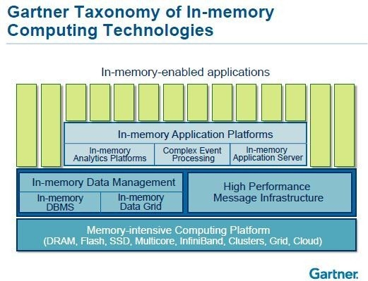](http://timoelliott.com/blog/wp-content/uploads/2013/04/taxonomy-of-in-memory.jpg)

So far, we’ve been talking just about in-memory DBMS. Here are some of the other ways the technology is used.

**In-memory data grids** have been around a long time. If any of us do web applications, we may be using some them. [Memcached](http://memcached.org/) is the one that comes to mind – an open-source product – where your data’s in memory, in the application, and scales across multiple computers, multiple servers. That technology’s been around a long time and enables some of the biggest web applications that we’re all using, including Amazon, including eBay, and all the spinoffs of those.

**High-performance messaging infrastructure**. Think about what happens if we want to send a message out to four or five thousand of our customers at a time. It’s an SMS message or whatever; in-memory’s going to be able to do that much quicker.

Wouldn’t it be nice if we’re an airline, and we’re cancelling a flight, to get those messages out quickly? Or, in retail, if we’re going to have a special pricing discount, we’re going to send out to all the customers registered on our site, and we’re a big retailer with one hundred thousand or a million customers, think about how high-performance messaging is going to happen.

**Complex event processing**. That’s what fraud detection is all about, especially for cloned cell phones, for trading fraud, for credit-card fraud, for anything where some analysis is taking place on streaming data coming into a computer and in real-time. We make a decision on an event that’s happening, and then do something about it.

**In-memory application servers**. These are necessary if we’re going to do this consolidation onto a single or double box of all our applications. Our application servers have to be in-memory, and they can’t be based on disk drives, or they’re not going to run as fast as all the other technology that is enabled with the applications running in the application server.

All of these together make up “in-memory technologies”. The providers of this technology are going to merge together and all of this is going to become an in-memory megadata platform over the next three to five years. Data grids are going to go away and just become part of the in-memory database. These two will be the first to merge, and they’re merging already with in-memory analytic applications and application servers.

That’s the future, as they merge together, which will enable you to run our whole business in memory.

## Drivers of in-memory computing

[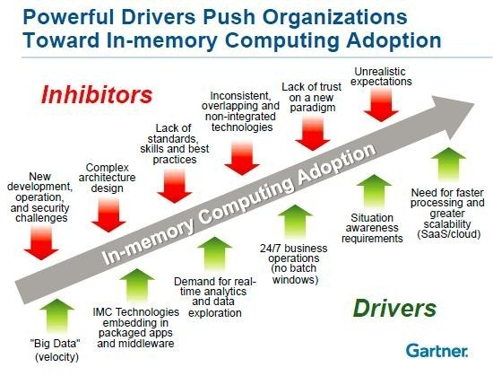](http://timoelliott.com/blog/wp-content/uploads/2013/04/drivers-of-in-memory.jpg)

So what drives all this? Well, big data. Now remember “big data” is not just about volume. When we mention big data with respect to in-memory, people think we’re crazy, because big data is a lot of data, and people say “I’m not going to put a petabyte in memory: it’s too expensive!”

“**Big Data**” is volume (big size) and/or velocity (how fast the data’s coming in) and/or the variety of data (unstructured data). In-memory can support velocity today, that’s one the first use case of it, high-speed data coming in through event processing, smart metering, etc. And it can support unstructured data. As the price comes down, as compression gets better, it’ll also get start to get larger and larger on volume of data.

**Real-time analytics.** For years, Gartner has said there is no such thing as “real-time.” Today, you are running analytics on data that is coming from a transaction system. If we have to say it that way, there’s a latency there. Some ETL or data integration process has to move data from the transaction system to the data warehouse before you can do those analytics. The only way we can do real-time analytics is if it’s being done on the transaction data when it’s completed. So that is one of the drivers for this.

**24×7 with no batch windows**. If you batch window drops to less than zero, you’re going to have to run things very quickly. Batch is going away. That Materials Requirement Planning batch run that takes six hours? If it starts to run in 3-4 seconds, it’s really no longer batch.

So the whole concept of batch disappears with in-memory technology. Any time you see words like “awareness” then you’re talking about in-memory. In order to make any applications aware of things it means real time, and it means you need the speed and low latency of in-memory technology to do it.

## Why you need an in-memory action plan

[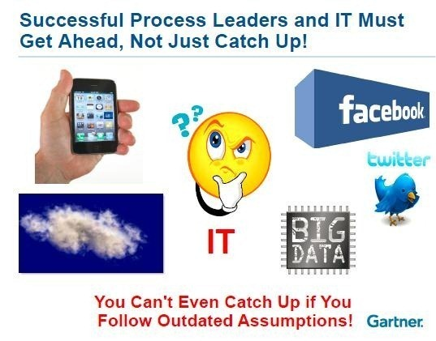](http://timoelliott.com/blog/wp-content/uploads/2013/04/in-memory-action-plan_thumb.jpg)

We need to change the way we look at IT infrastructure, applications, and the infrastructure that’s running those applications. **Truly, with some of these new technologies like in-memory technology, there are no barriers, things that we can’t do. Words like “no we can’t do it” start to go away.**

[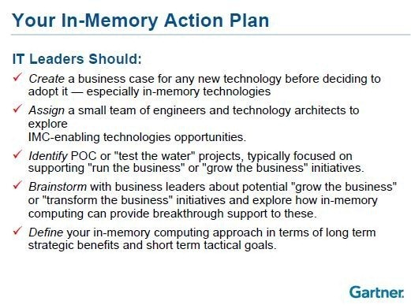](http://timoelliott.com/blog/wp-content/uploads/2013/04/in-memory-action-plan-2_thumb.jpg)

Its not that it’s going to be cheap, Its just that there’s not going to be bumps in the road as we’re doing it, but **things that we really thought were not possible are possible now. Period.**

What do we do in our organization to start to adopt or use some of the in-memory technologies? We *are* going to spend money on this. Whether the TCO is less or not, we still have to build our skills, we still have to buy applications, we still have to buy the technology and infrastructure and things like that.

# Expectation

## In-memory is going to change the way everything is done

*In-memory computing will have a long term, disruptive impact by radically changing users’ expectations, application design principles, products’ architecture and vendors’ strategy*

This is going to change the way everything is done. **Everybody industry will be running their entire IT organization in-memory in the next 15 to 20 years**. It’s not going to happen overnight. But within the next 15 years, they will run their whole operation in memory. Industries won’t have tape drives or disk drives. They’ll be using flash and memory. Flash will be their backup and archive, and memory is where they’re going to run everything. And that’s the expectations.

We are expecting to run our whole business in-memory in 10 or 15 years, but it’s going to be on a single server the size of what we think of as a desktop server, plugged into the wall with no special air conditioning needs. That’s the kind of miniaturization and speed that in-memory is bringing to the table, with huge savings.

I know many of us are thinking, “It’s not talking about high availability or disaster recovery”. All of that is coming — and it also is miniaturized. We’re not going to run our business on one of these, we’re going to run our business on two of them, sitting next to each other, duplicating everything it does, synchronously. That’s our high availability. Then we’ll put another one somewhere else, in somebody’s home, 250 or 800 kilometers away, and that’s our disaster recovery center. We hire a disaster recovery manager in Perth, and put the disaster recovery in his house — that’s the way it is expected be in the future.

# References

1. <http://www.techopedia.com/definition/28539/in-memory-computing>
2. IBM Data Magazine “What Makes In-Memory Computing So Next Generation?” By Nancy Hensley
3. Forbes Article “IT Revolution: How In Memory Computing Changes Everything” By Eric Savitz and Don Basile (CEO of Voilin Memory)
4. Forbes Article “In-Memory Computing and the Emergence of Tier -1 Storage” By John Webster
5. <http://www.tibco.com/products/automation/in-memory-computing>
6. <http://www.gridgain.com/in-memory-computing-in-plain-english/>
7. Donald Fienberg, Gartner VP and Distinguished Analyst on “Nexus of Forces” during ANZ/APJ innovation analytics tour.
8. Deloitte internal studies “In Memory Computing Technology – The holy grail of analytics” Marcel Grandpierre, Georg Buss, Ralf Esser
9. ISACA journal: “In-Memory Computing-Evolution, opportunity and risk” by William Emmanuel Yu
10. “SAP HANA and In Memory Computing” by [Lars Breddemann](http://scn.sap.com/people/lars.breddemann), [Sujit Hemachandran](http://scn.sap.com/people/sujit.hemachandran), [Vera Sayevich](http://scn.sap.com/people/vera.sayevich)
11. “In-Memory Computing Is Racing Towards Mainstream Adoption” by Jenessa Rivera and Rob van der Meulen of Gartner